**Alternate to E-collar - *Cover Me by Tui*** Body suite for surgical recovery

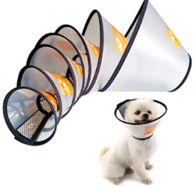

Elizabethan collars are your best defense for preventing your pet from licking or removing sutures. The first 10 days are so important to aid healing. These collars can be awkward for both your pet and you and are often are more difficult for animal’s with shorter legs. They take a while to get used to but most pets will adjust if left to learn how to maneuver. They are needed until the surgical site has healed completely.

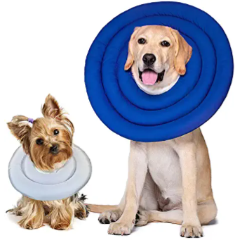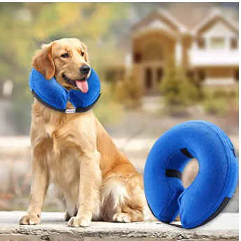

Blow up collars often do NOT work well by themselves – dogs are able to work around them and get their mouths on the incision to lick or chew. The collar on the left side work better than the thicker/shorter blow up collars on the right.

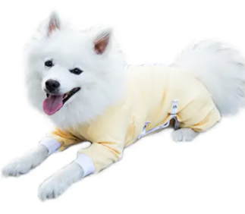Body suits - The one on the left is correct. The suits must have sleeves on them to fully cover the belly and inguinal area for spay or castration.

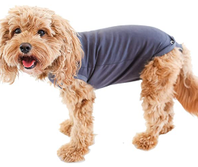NO – do not use this kind for spay or castration. The suits needs sleeves to protect the under belly and must fully cover the surgical site. You will need to unsnap before going out to eliminate. If just snaps on like a baby “Onesie”, your pet will be able to push it out of the way and get to an abdominal incision from a spay or castration.

Please see **tulanescloset.com** or on line at Chewy or Amazon. The product is ***Cover Me by Tui options - Short sleeve or Long sleeve.***

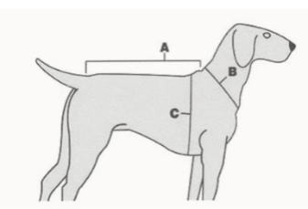**1. Measure length of your pet's back fro 38" - 42" Newfoundland - up to 120 lbs m the base of the neck to the base of the tail. (A)**

**2. Measure neck circumference. (B)**

**3. Measure the broadest part of the chest. If the measurement is between sizes or if your pet has a stouter build, select a garment one size larger for a proper fit. (C)**

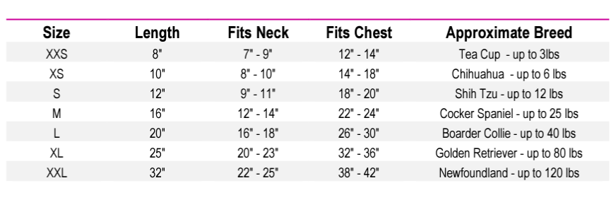

**If you have any further questions about sizing your pet. Office 636-447-1659 CST Monday through Friday 9am to 5pm**